**Outline:**

1. Abstract 1: We use ratiometric measurements from genetically-encoded redox sensors to learn about how redox processes affect aging in *C. elegans*. If we know the precision of our ratiometric measurements, we can predict the range of glutathione redox potential values that our sensor is well-suited to measure within a certain accuracy.
   1. Concept 1: If we have many redox-sensitive GFP proteins in a cell, we understand how to use the protein’s excitation-emission pattern to estimate the cell’s redox state.
      1. Graph 1: Excitation-emission spectrum
      2. Graph 2: Spectrum: for a mixed population, spectrum is the weighted average of the two extremes.
      3. Graph 3: A ratio measurement gives a concentration-independent map to the fraction of sensors that are oxidized and the redox potential.
      4. Graphs 4 and 5: A ratiometric can be mapped into a fraction oxidized and a redox potential
      5. Equations 1-4: The map between and the fraction oxidized and redox potential can be described by just a few parameters.
      6. Graphs 6 and 7: The map between and the fraction oxidized and redox potential can be altered by a value called .
      7. Graphs 8 and 9: The choice of the second wavelength in the ratiometric output has a predictable effect on the map between , the fraction oxidized, and redox potential.
   2. Concept 2: If we know the precision of our ratiometric measurements, we can estimate the accuracy of our predicted values of the redox potential.
   3. Concept 3: If we know the precision of our ratiometric measurements, we can predict the range of redox potential values that our sensor is well-suited to measure within a certain accuracy.
2. Abstract 2: (TBD) If we know the precision of the measurements obtained from any ratiometric sensor, we can predict the range of values that the sensor is well-suited to measure within a certain accuracy.
3. Abstract 3: (TBD) We have created a publicly-available tool as a resource to identify the range of values a sensor is well-suited to measure within a certain accuracy.

## **Concept 1:** If we have many redox-sensitive GFP proteins in a cell, we understand how to use the protein’s excitation-emission pattern to estimate the cell’s redox state.

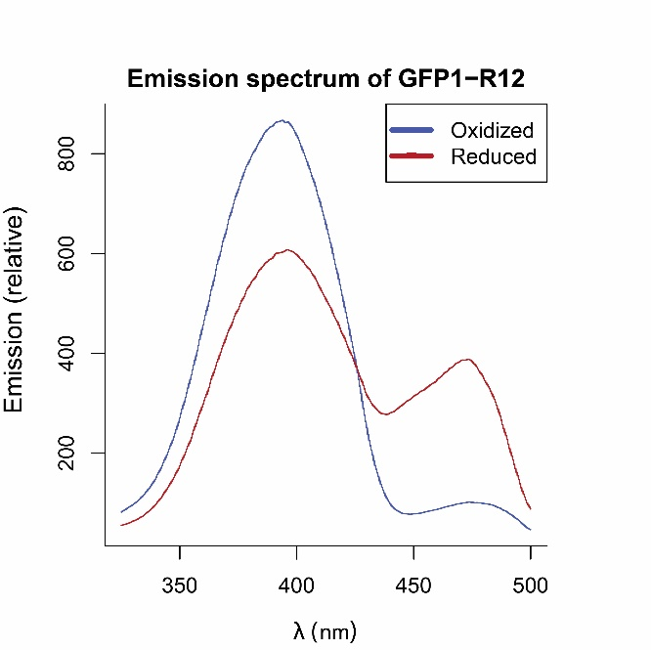

### **Graph 1.** A redox sensor can be oxidized or reduced, and each sensor has a characteristic excitation-emission pattern.

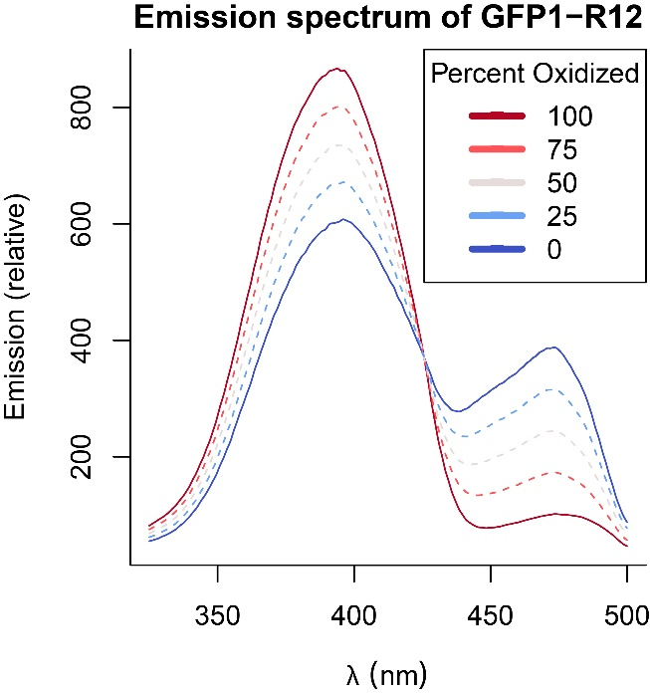

**Graph 2.** When you excite a population of sensors, the resulting spectrum is a weighted average of the emissions from the oxidized and reduced sensors.

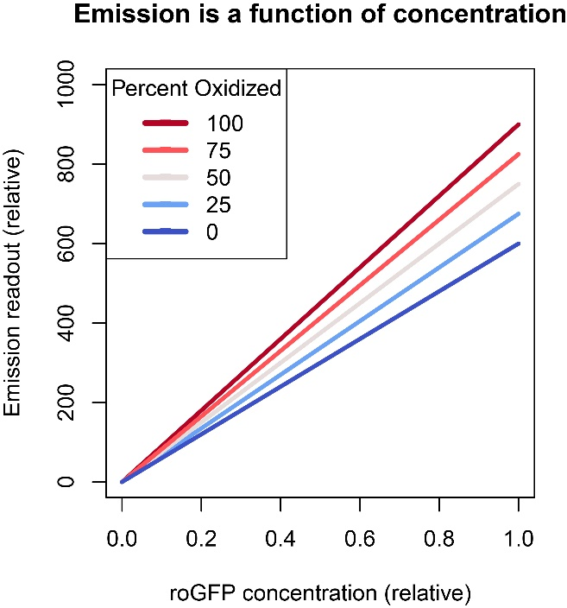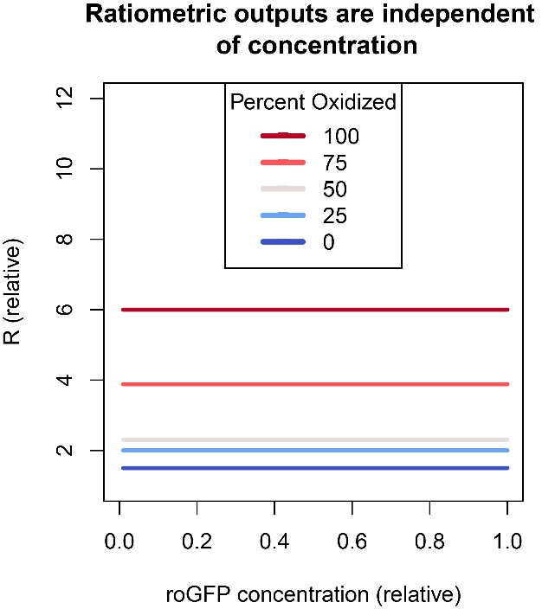

**Graph 3.** Emission from a single wavelength depends on concentration, but a ratiometric emission does not (see derivation 1). Since, in an *in vivo* setting, we do not know the concentration of sensors, we take a ratiometric output.

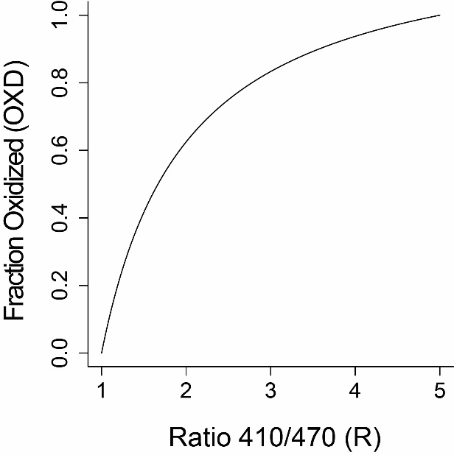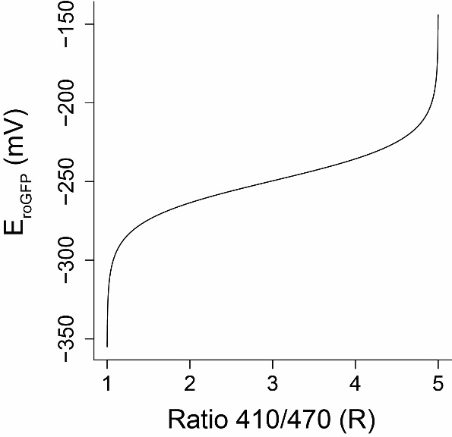

**Graphs 4 and 5.** A ratiometric output between two wavelengths can be mapped into two chemically meaningful values: the fraction of sensor molecules oxidized and the redox potential of the reaction between the redox sensor and the glutathione redox couple.

**Equations 1-4.** The map between ratio and the fraction oxidized (OxD) and the redox potential (E) depend on three or four parameters, respectively: the maximum ratio (, the minimum ratio (, the ratio ( between oxidized and reduced emission in the *second* wavelength in the ratio ( in see derivation 2) and, for redox potential, the midpoint potential . These parameters are constants but vary depending on both the particular sensor and the wavelengths being used to take the ratio measurement.

*In general:*

**(1)**

**(2)**

*For roGFP1-R12*, :

**(3)**

**(4)**

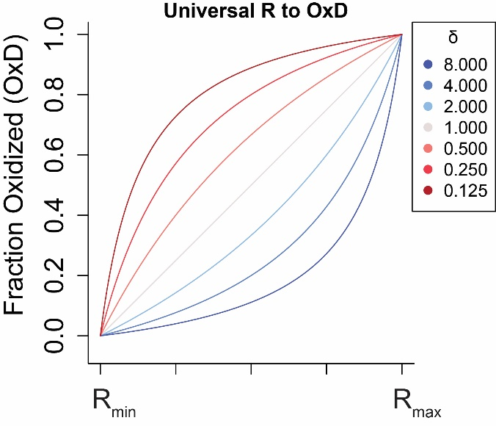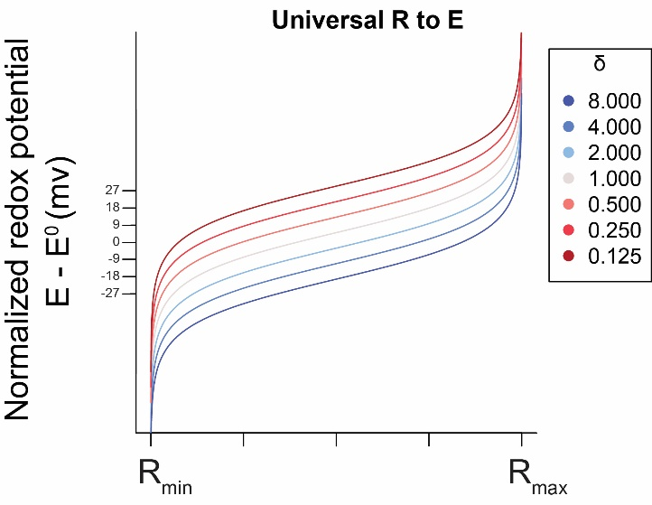

**Graphs 6 and 7.** The ratio between the emission value of an oxidized and reduced emission at the second of the two ratio wavelengths, which we call , changes the way that the ratio emission maps to the fraction oxidized and redox potential.

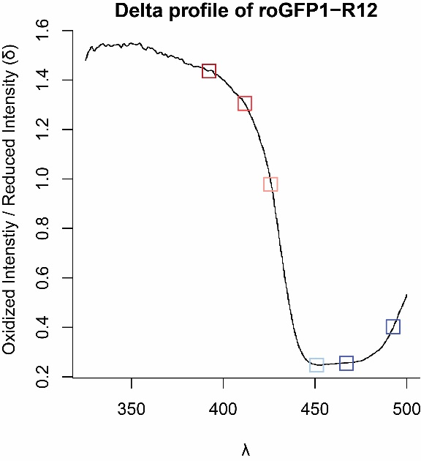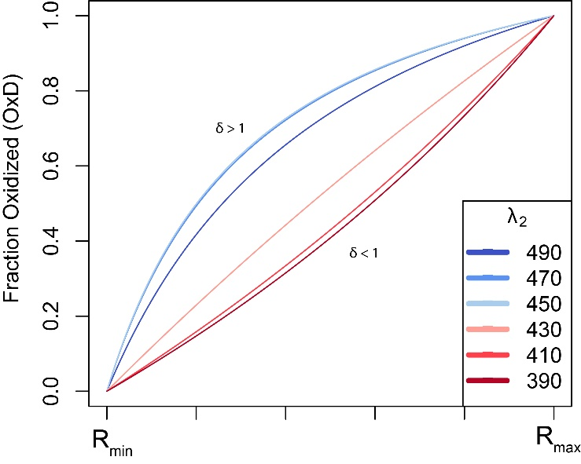

### **Graphs 8 and 9.** In graph 4, we chose as our second wavelength but, had we chosen a different wavelength, our map between ratio and fraction oxidized would have been altered based on the ratio between the oxidized and reduced emission at that wavelength, or .

## **Concept 2:** Our measurement of ratiometric emission has limited precision and we understand how that lack of precision alters the accuracy of interpretation of the redox state.

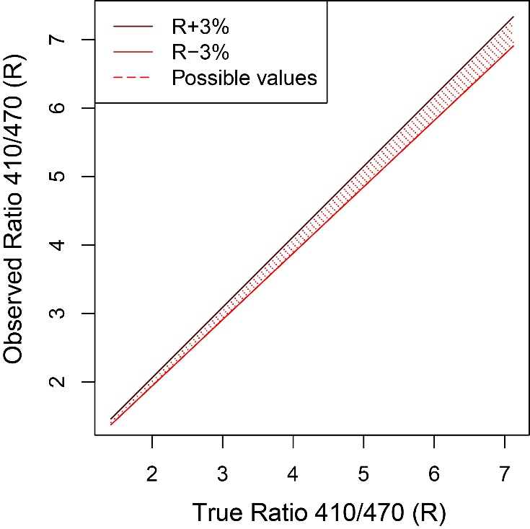

### **Graph 9.** Empirically, we observe a precision in the ratiometric emission of around 3%. Given that precision, there is a small range of emission values that we could observe for any true emission value.

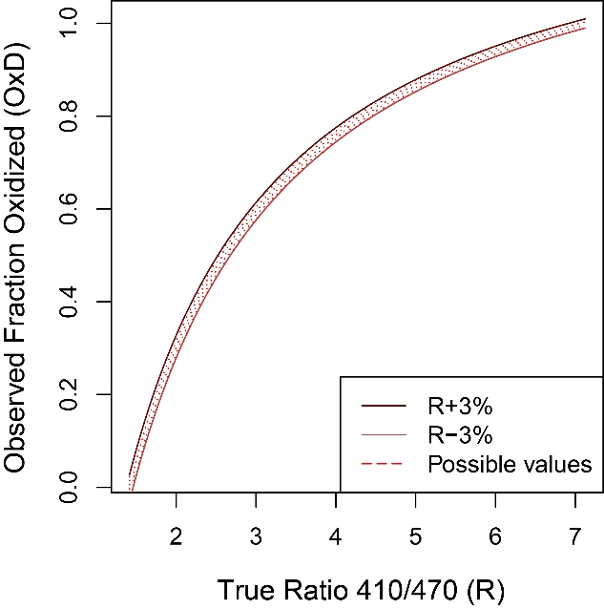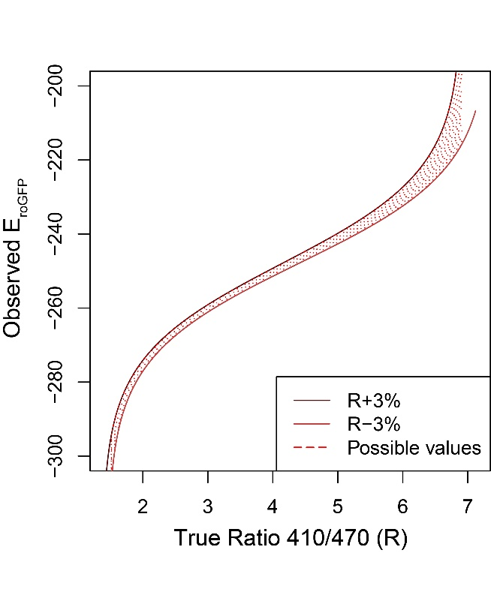

### **Graphs 10 and 11:** Since we know the range of ratiometric emission values we would expect to see with a precision of 3%, we can also determine the range of values we could predict for the fraction of sensors that are oxidized and the associated redox potential.

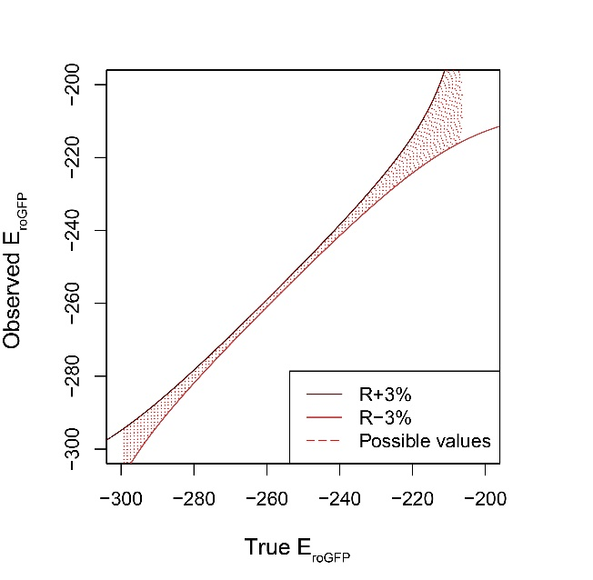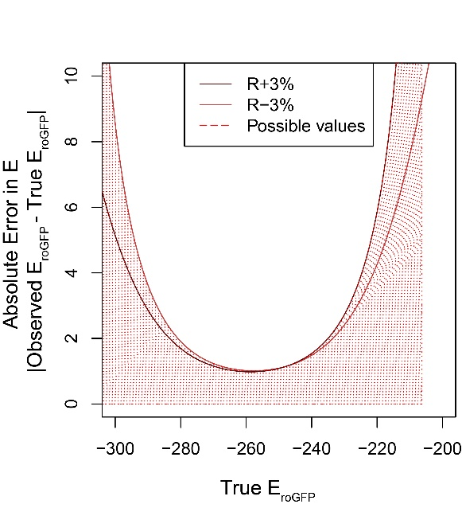

**Graphs**

## **Concept 3:** For any set of sensor measurements with a known precision, we can predict the ranges of redox potentials that the sensor can accurately measure.

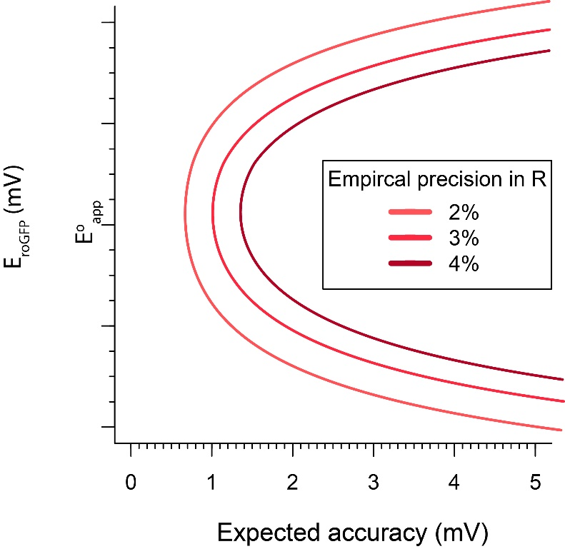

### **Graph 12.** The more precisely we are able to measure the ratiometric emission, the more accurately we can measure a wider range of redox potentials.

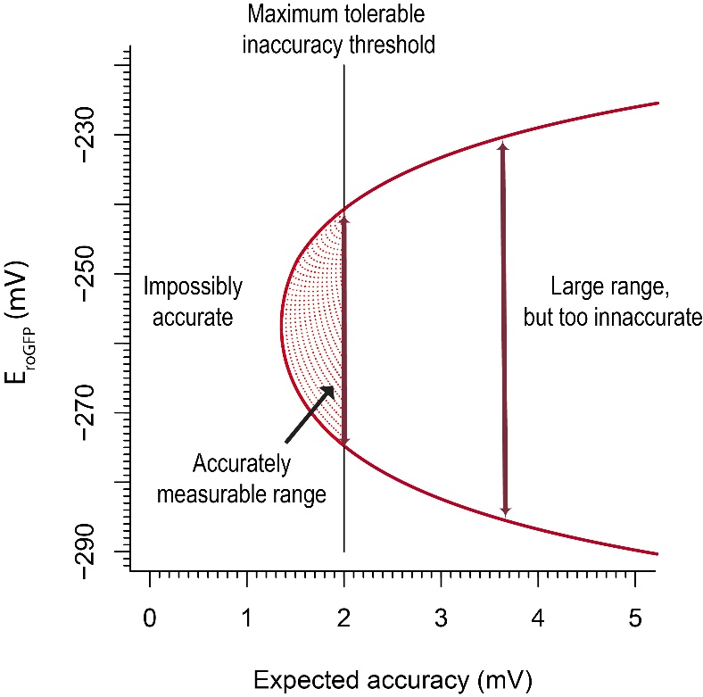

### **Graph 13.** At some empirical level of precision in ratiometric emission, we can find the range of redox potentials that a sensor can measure accurately.

**Derivations**

**Derivation 1.** A ratio measurement is independent on concentration.

If all the sensors are in an oxidized or reduced state, the emission intensity that we record at any wavelength is equal to the emission of one sensor at that wavelength, multiplied by the total number of sensors:

In a mixed population, the emission intensity is a weighted average of the two extremes:

By taking the ratio between the intensity at and , the total number of molecules cancels:

**Derivation 2.** The map between R and OxD and E rely on three and four parameters, respectively.

Using the definition of from Derivation 1, and assuming that . We can also define the minimum possible value of as and the maximum possible value of as .

Divide by :

Group denominator:

OxD is thereby a function of one variable () and three sensor-specific constants (, , and which we, for convenience, write as .